Wellbeing Newsletter
Issue 1
Dear Parents and Carers as we move into the Christmas term and the days are becoming shorter, it can be easier for our mood to lower and utilising the wellbeing strategies we know becomes harder. Taking control of our wellbeing is vital in being able to thrive both inside and outside the classroom.

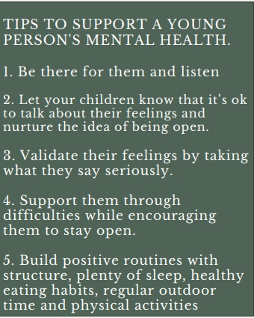
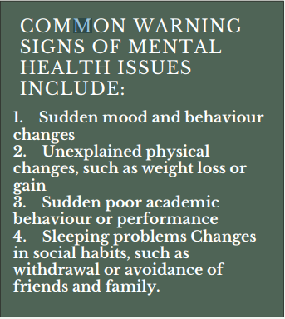

Tips and Resources to Help you Prioritise Self-Care As You Settle Back After a Break
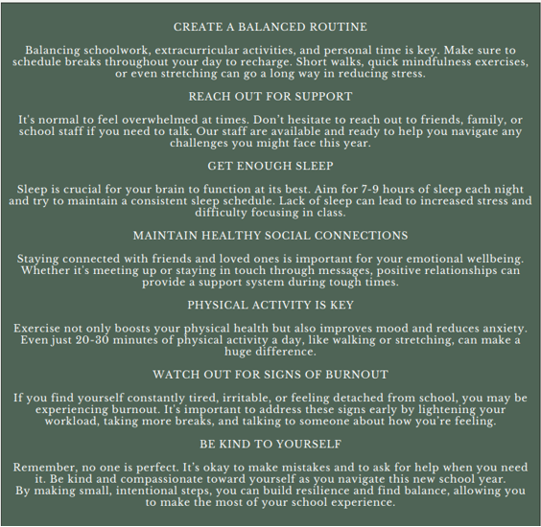

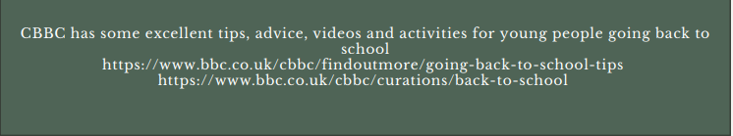
Wellbeing Ambassadors
If you would like to talk to someone about how you are feeling or would like some peer support for any bullying you may have experienced in the past, then come and speak to our Wellbeing Ambassadors. There is a link on your google classroom or speak to your lead coach who can refer you.
For world mental health day the Ambassadors put on a tea and talk event with a green station and dinosaur to raise money for Mind. This was an excellent event where nearly £80 was raised which will go directly to support people who need additional counselling.
If you would like to become part of the team please write a letter to Mrs Bryant explaining how you would be a benefit to the team and why you are interested in anti-bullying and wellbeing.

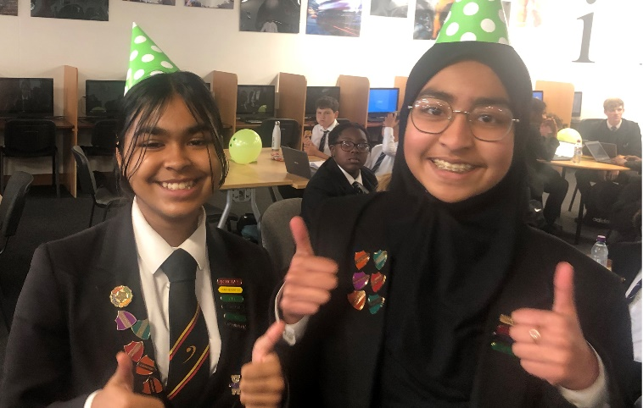

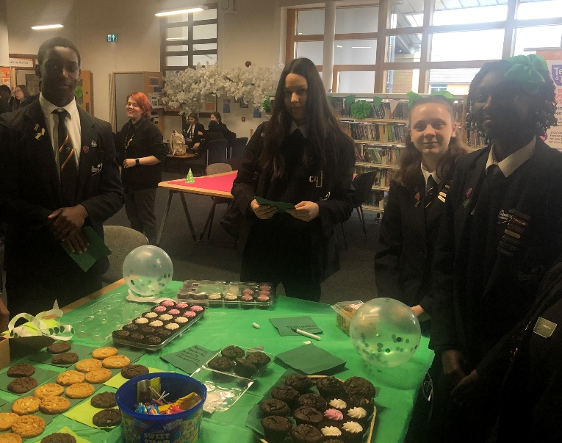

Support For Parents.
Being a parent to a teenager brings a whole set of new challenges. Place2Be is an excellent resource which provides expert advice for all parenting questions
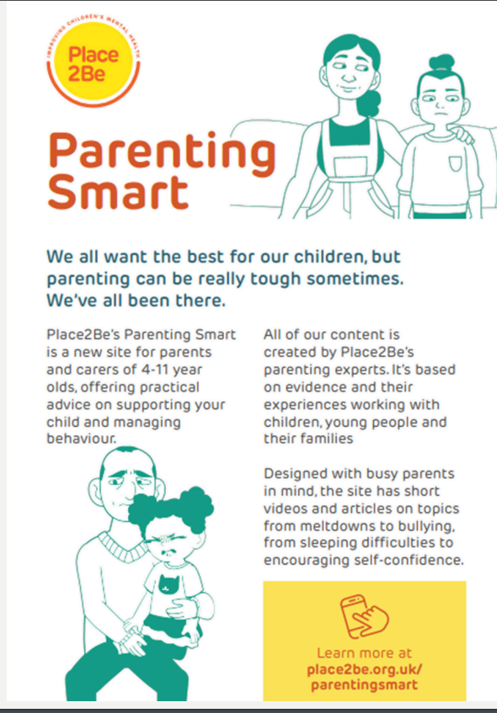

Useful links for young people and parent/carers
Kooth
Free online support for young people. Kooth counsellors are online Monday-Friday, 12 noon till 10pm and weekends, 6pm till 10pm
www.kooth.com
Young Minds
Young Minds is the UK’s leading charity committed to improving the emotional wellbeing and mental health of children and young people. Just as people’s bodies can become unwell, people’s minds can become unwell too. Mental health problems are more common than you might think – three children in every classroom have a mental health problem.
Young Minds offer information to young people and children about mental health and emotional wellbeing. If you need to talk, they can let you know about organisations that listen, plus they offer online support and info
www.youngminds.org.uk
ChildLine
Childline is the UK’s free helpline for children and young people. It provides a confidential telephone counselling service for any child or young person with a problem. It comforts, advises and protects. So, if you are worried about anything, big or small – don’t bottle it up. It can really help if you talk to someone. If there is something on your mind, ChildLine is there for you. You can visit the Childline Explore section for advice and information on a range of topics. Also, you can get support on the online message boards. ‘Everyone helps each other out and is going through the same things as me – it’s a really welcoming place’ Freephone 0800 1111 (24 hours and the call won’t show on your phone bill)
www.childline.org.uk
The Mix
The Mix Free, confidential telephone helpline finding young people the best help whatever the problem. Provides free connections to local or national services, and can text information to callers’ mobile phones. Freephone 0808 808 4994 (7 days a week 1pm-11pm)
www.themix.org.uk/
Samaritans
Samaritans’ volunteers listen in confidence to anyone in any type of emotional distress, without judging or telling people what to do. Call 0116 123 (24 hours, 7 days a week)
www.samaritans.org.uk
FRANK
Confidential information and advice for anyone concerned about their own or someone else’s drug or solvent misuse. Freephone 0800 77 66 00 (24-hour service, free if calling from a landline and won’t show up on the phone bill, provides translation for non-English speakers)
www.talktofrank.com
B-EAT
Youth helpline Online community information, help and support for anyone affected by eating disorders. Call 0845 634 7650 (Monday to Friday evenings, from 4.30pm to 8.30pm, and Saturdays, 1.00pm – 4.30pm)
www.b-eat.co.uk
Kidscape
Kidscape are the first charity in the UK established specifically to prevent bullying and sexual abuse. The website offers advice and practical skills on how to deal with bullying. Remember, no-one deserves to be bullied. Nearly everyone is bullied at some time in their lives: by brothers and sisters, by neighbours, by adults or by other children/young people. If you are being bullied, you may feel scared, vulnerable and quite alone but you owe it to yourself to try and sort out the situation so that the bullying stops.
www.kidscape.org.uk
It Gets Better Project
Project created to inspire hope for young people facing harassment. A place where young people who are lesbian, gay, bi, or trans can see clips of other people’s coming out stories. www.talktofrank.com Brook Advisory Service Brook is the UK’s leading provider of sexual health services and advice for young people under 25. The charity provides free and confidential sexual health information, contraception, pregnancy testing, advice and counselling, testing and treatment for sexually transmitted infections and outreach and education work.
www.brook.org.uk
Winston’s Wish
The death of a parent, brother or sister is one of the most fundamental losses a child will ever face. At Winston’s Wish, they believe that bereaved children need support to make sense of death and rebuild their lives. The Winston’s Wish Helpline offers support, information and guidance to all those caring for a bereaved child or young person. Helpline 08452 03 04 05 (Monday – Friday, 9am to 5pm, and Wednesday evenings, 7pm to 9.30 pm)
www.winstonswish.org.uk

