LITERACY INITIATIVES:
Overview:
Literacy is fundamental to effective communication. The ability to speak and listen, read and write helps us to interact with and make sense of the world. These skills are the great enablers that empower us to adapt, engage and thrive within all manner of social and workplace settings. Research provides us with a litany of statistics regarding the importance of literacy, but the reality is simple: those who struggle to read and write are not empowered to make the most of their lives.

At The Gateway Academy, we recognise that everyone has had different experiences that affect their literacy levels. To support all of our young people, we have started a 3 year teaching and learning programme to improve literacy skills that will have a lasting benefit for all students who come through our gates.
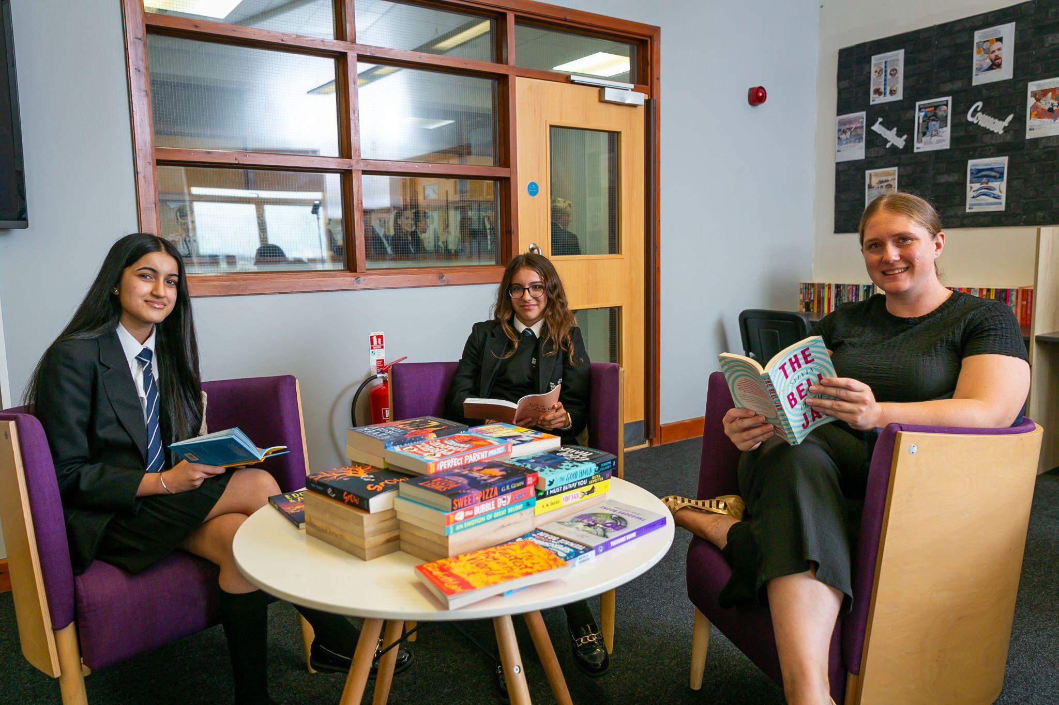
Vocabulary Acquisition:
Words are the building blocks of communication and it’s a simple principle that we follow: the more you know, the more you know. As such, we have developed a bespoke vocabulary acquisition strategy that looks to introduce new words to students with a systematic and structured approach.

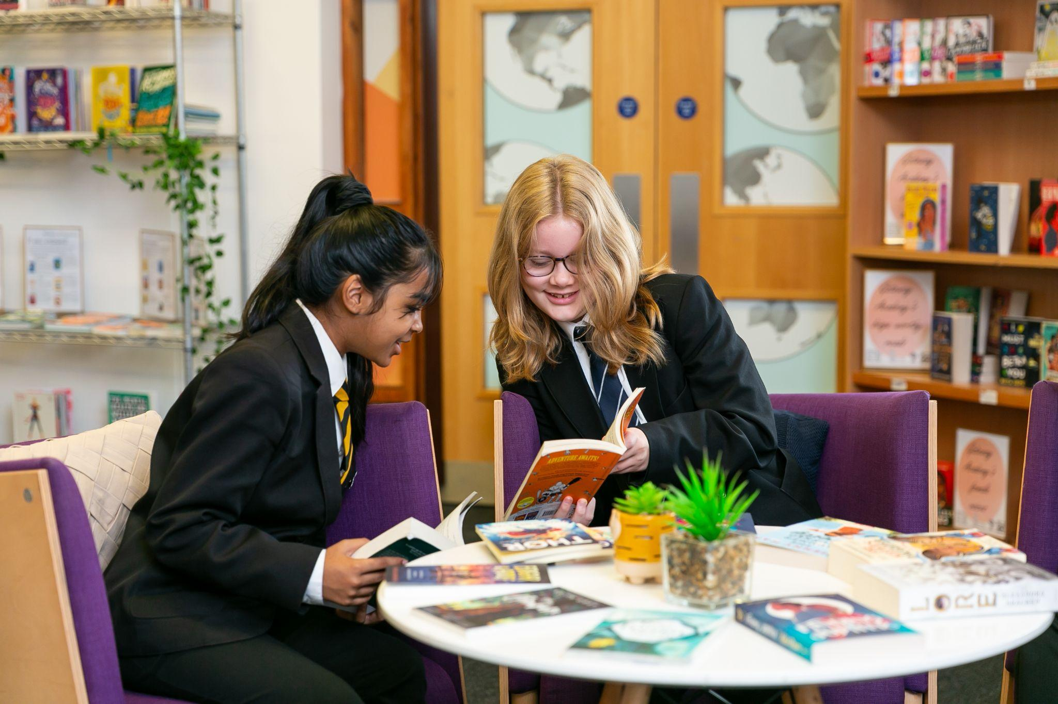
Academic Reading:
To reinforce Vocabulary Acquisition, we have placed academic reading at the centre of our curricula to ensure all students are exposed to high-quality subject-specific texts that help to deepen students’ understanding of the topic and subject. This is designed to ensure students are aware of the different forms and styles of reading that are particular to different subject areas, whether this be a piece of literary criticism, a science report or a historical investigation.

Chunk - Stop - Do:
The Academic Reading that is taking place in lessons is supported through the development of a whole school approach to reading. This includes developing the ability of students to decode unfamiliar words. Simple questions such, ‘are there parts of the word that you recognise?’, ‘what do those parts mean?’, ‘does it sound positive or negative?’, ‘does the prefix change the meaning of the word?’, can help to unlock the meaning of words on a more independent basis.

Support for developing readers:
At the Gateway Academy, we believe that it is our duty to ensure our pupils become as highly literate as possible. If we feel as if our pupils are in need of further support with their reading, we are proactive in putting steps in place to support our pupils in becoming as highly skilled with their literacy as possible. We have two highly effective support schemes which we run at the academy to support the reading of our pupils.
If you have concerns about your child’s reading and would like to discuss further support, please get in touch with Dan Bedford (dan.bedford@theglc.org.uk)

Thinking Reading
We work closely with both Literacy Assessment Online, and Thinking Reading (an industry leading reading program), in order to ensure that our students get the absolute best experience possible. Thinking Reading allows our students to participate in fast paced and targeted lessons that ensure any gaps in their reading skills are developed.
Peer Reading
We are excited to have recently launched our Peer Reading Scheme. Identified pupils have been paired with a Year 10 pupil who they meet once a week for a reading session. In this session, our Year 10 pupils lead the session which will develop both their reading skills as well as a love of reading. Pupils involved in the Peer Reading scheme will select a text that they want to read for these sessions. This is a fantastic opportunity for our pupils to learn and develop for their peers.

Love of reading:
Book Buzz
At the academy, we engage with the Book Trust’s Book Buzz campaign yearly. We ensure that all year 7 and 8 students are provided with an engaging new text in the run up to the end of the first term. Students get the opportunity to select one of 16 titles that are picked by a panel of expert judges. The texts are all selected to ensure that they are of high quality, are suitable for the age range and encourage an enjoyment of reading.

Author Visits
We have a number of special events related to reading over the course of the school year, including regular author visits and opportunities to celebrate students who are reading regularly.
The celebrated author Dan Freedman attends the academy annually to complete an assembly with our year 7s and a writing workshop with our year 8 students. We also have also hosted virtual Author Meets with Catherine Johnson and Neil Gaiman.
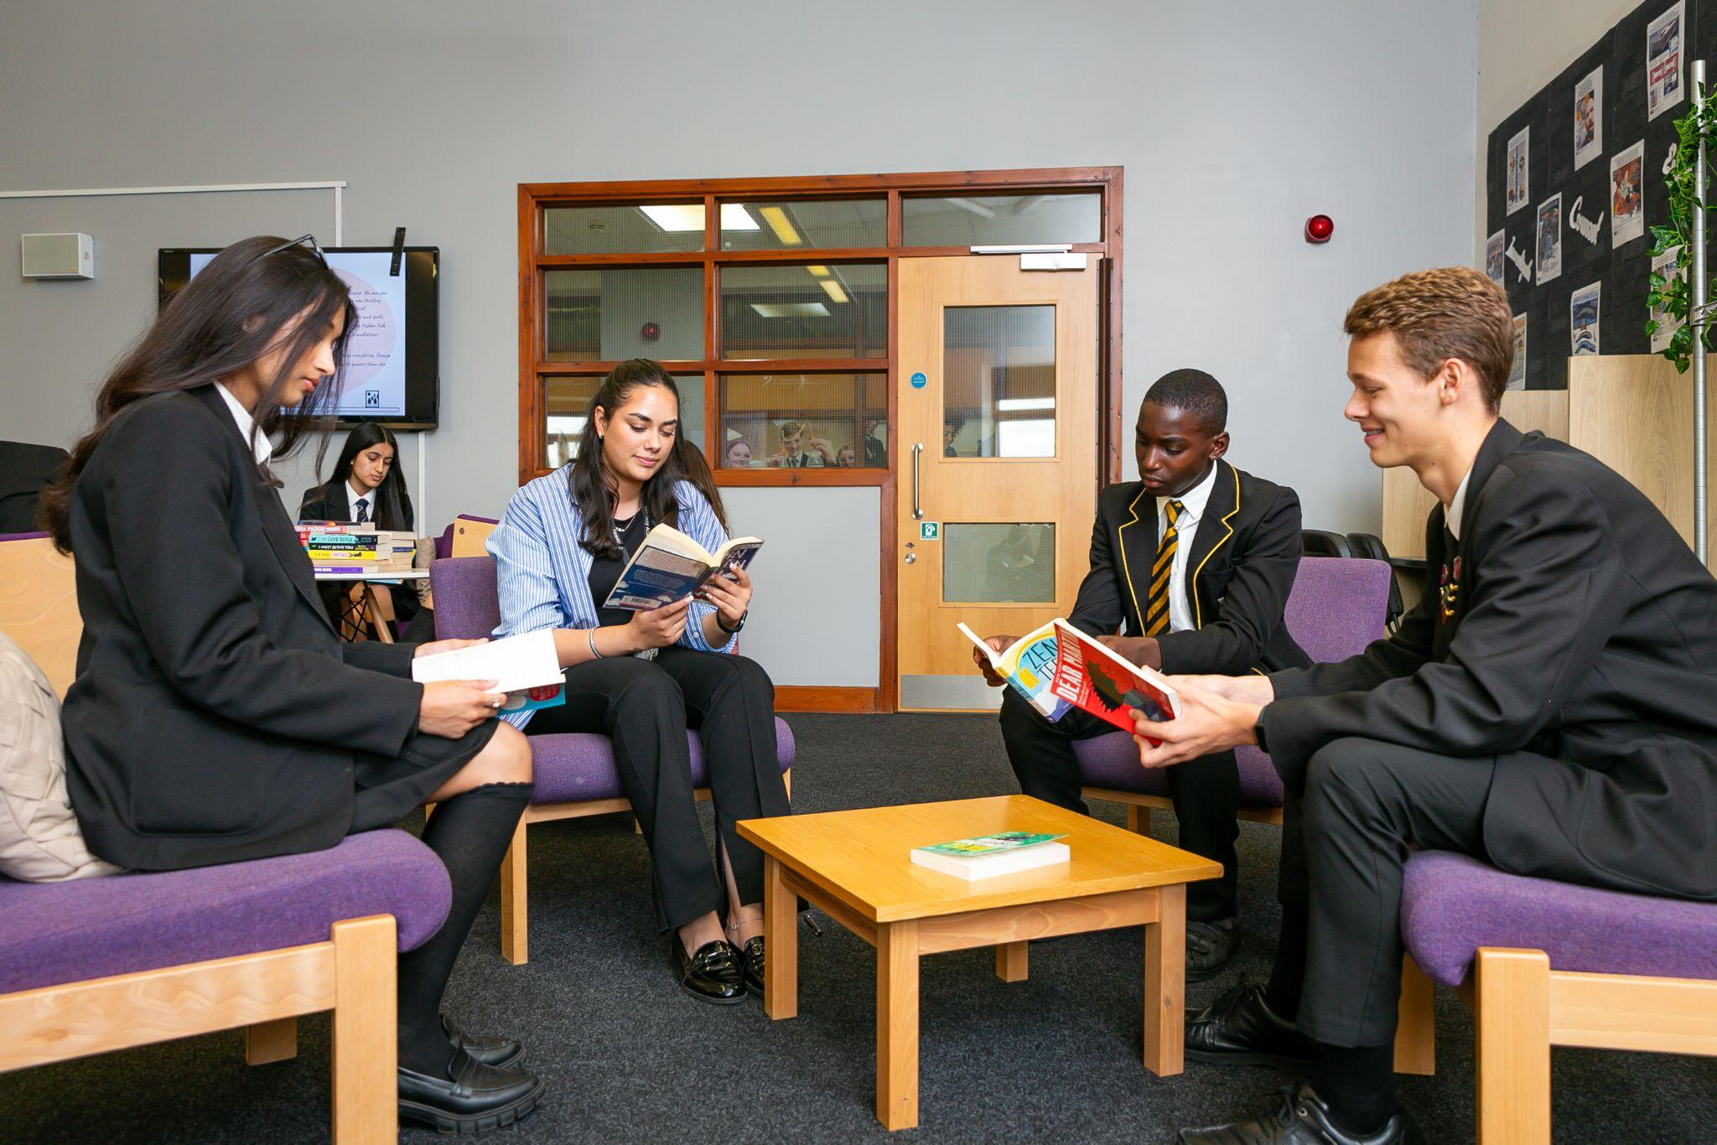
Literature Lounge
Our pupils have access to our fully stocked Literature Lounge, at break times and lunch times. This space is specifically located in a quiet part of the academy building to ensure our students have a quiet space to enjoy a new book. The cosy setting and expansive range of modern fiction and non-fiction makes it the perfect space for our students to escape the hustle and bustle of school life and venture into a world of literature.
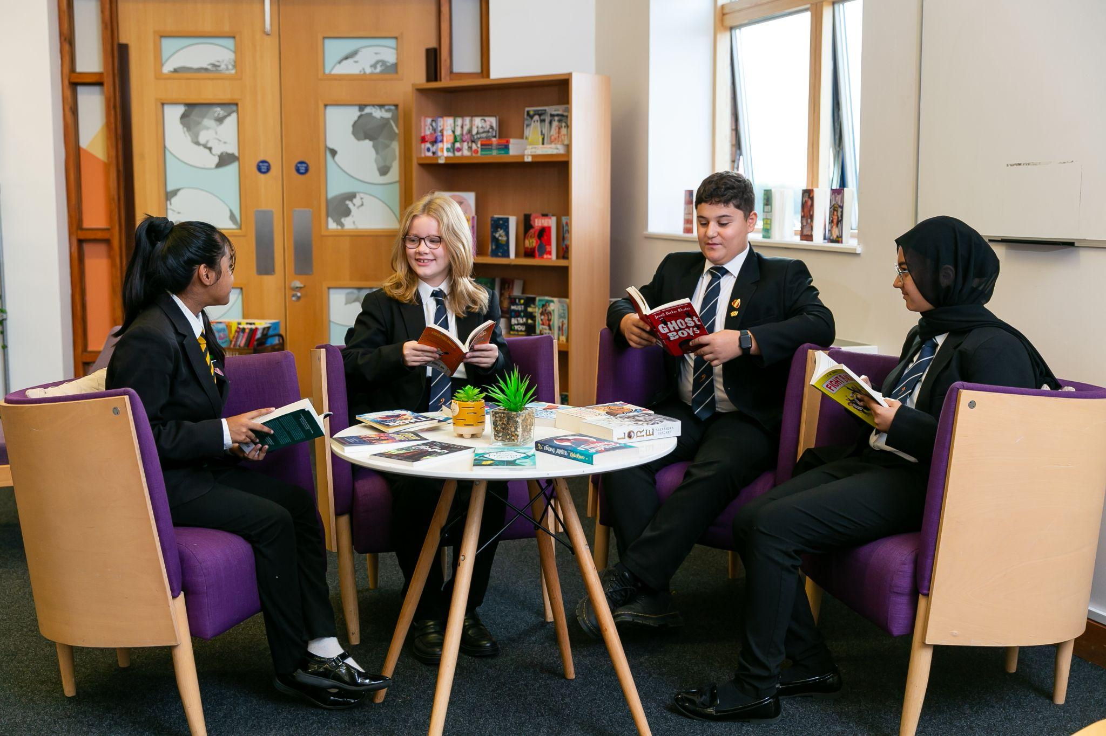
School Library
Our pupils have access to our school library before school, at break times, and after school. This is a study space which has a wide range of texts on offer- both fiction and nonfiction, some aimed at our pupils’ studies, others for the enjoyment of reading. Pupils have full access to all these and are able to take any book home with them.
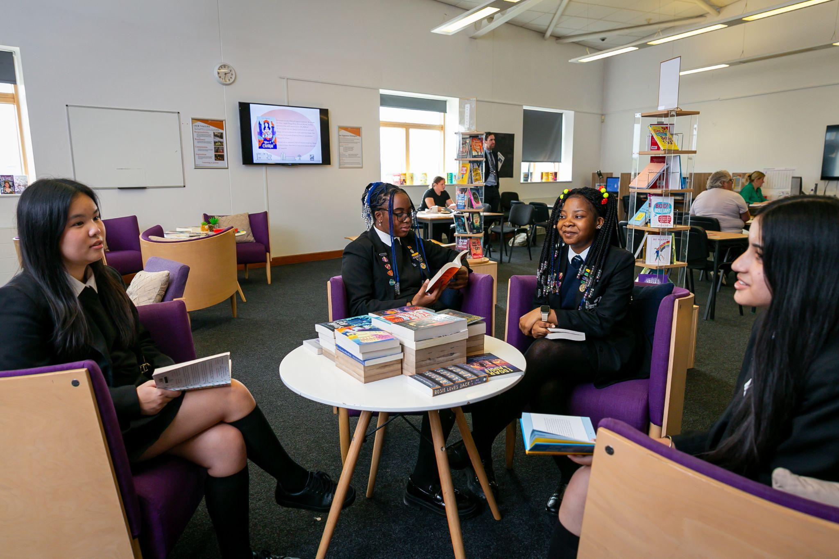
Reading Club
During book club we, as a collective, pick a book that we would all like to read. Every week we then read parts of the book in chronological order and then do activities based on what we have read so far- for example kahoot quizzes, drawing an image of what we imagine characters/scenes to look like etc. The purpose of book club is to not only read books, but to promote a community for creativity and confidence outside of the classroom.

Book club currently takes place every Thursday at 3PM in Rm 2406.

Next steps:
Moving into the next academic year, we will build on these strands of literacy teaching by focusing on the intricacies of the writing process across all of our subject areas. We will explore what it means to write like an historian, craft essays like a literary critic, and produce well-researched and tested reports like a scientist.

Parents - Tips to Support at Home:
At the Gateway Academy, we understand the pivotal role parents and carers play in nurturing a love for reading in their children. Engaging with your child's reading journey is a wonderful way to foster a lifelong appreciation for literature. Here are some tips and strategies to support your child’s reading development:
1. Establish a Reading Routine:
Encourage a consistent reading schedule at home. Set aside a specific time each day for reading, whether it's before bedtime or during a quiet part of the day. Consistency helps build the habit of reading.

2. Lead by Example:
Demonstrate the importance of reading by being a reading role model. Let your child see you enjoy books, magazines, or newspapers. Show enthusiasm about the stories you read and share your own reading experiences.

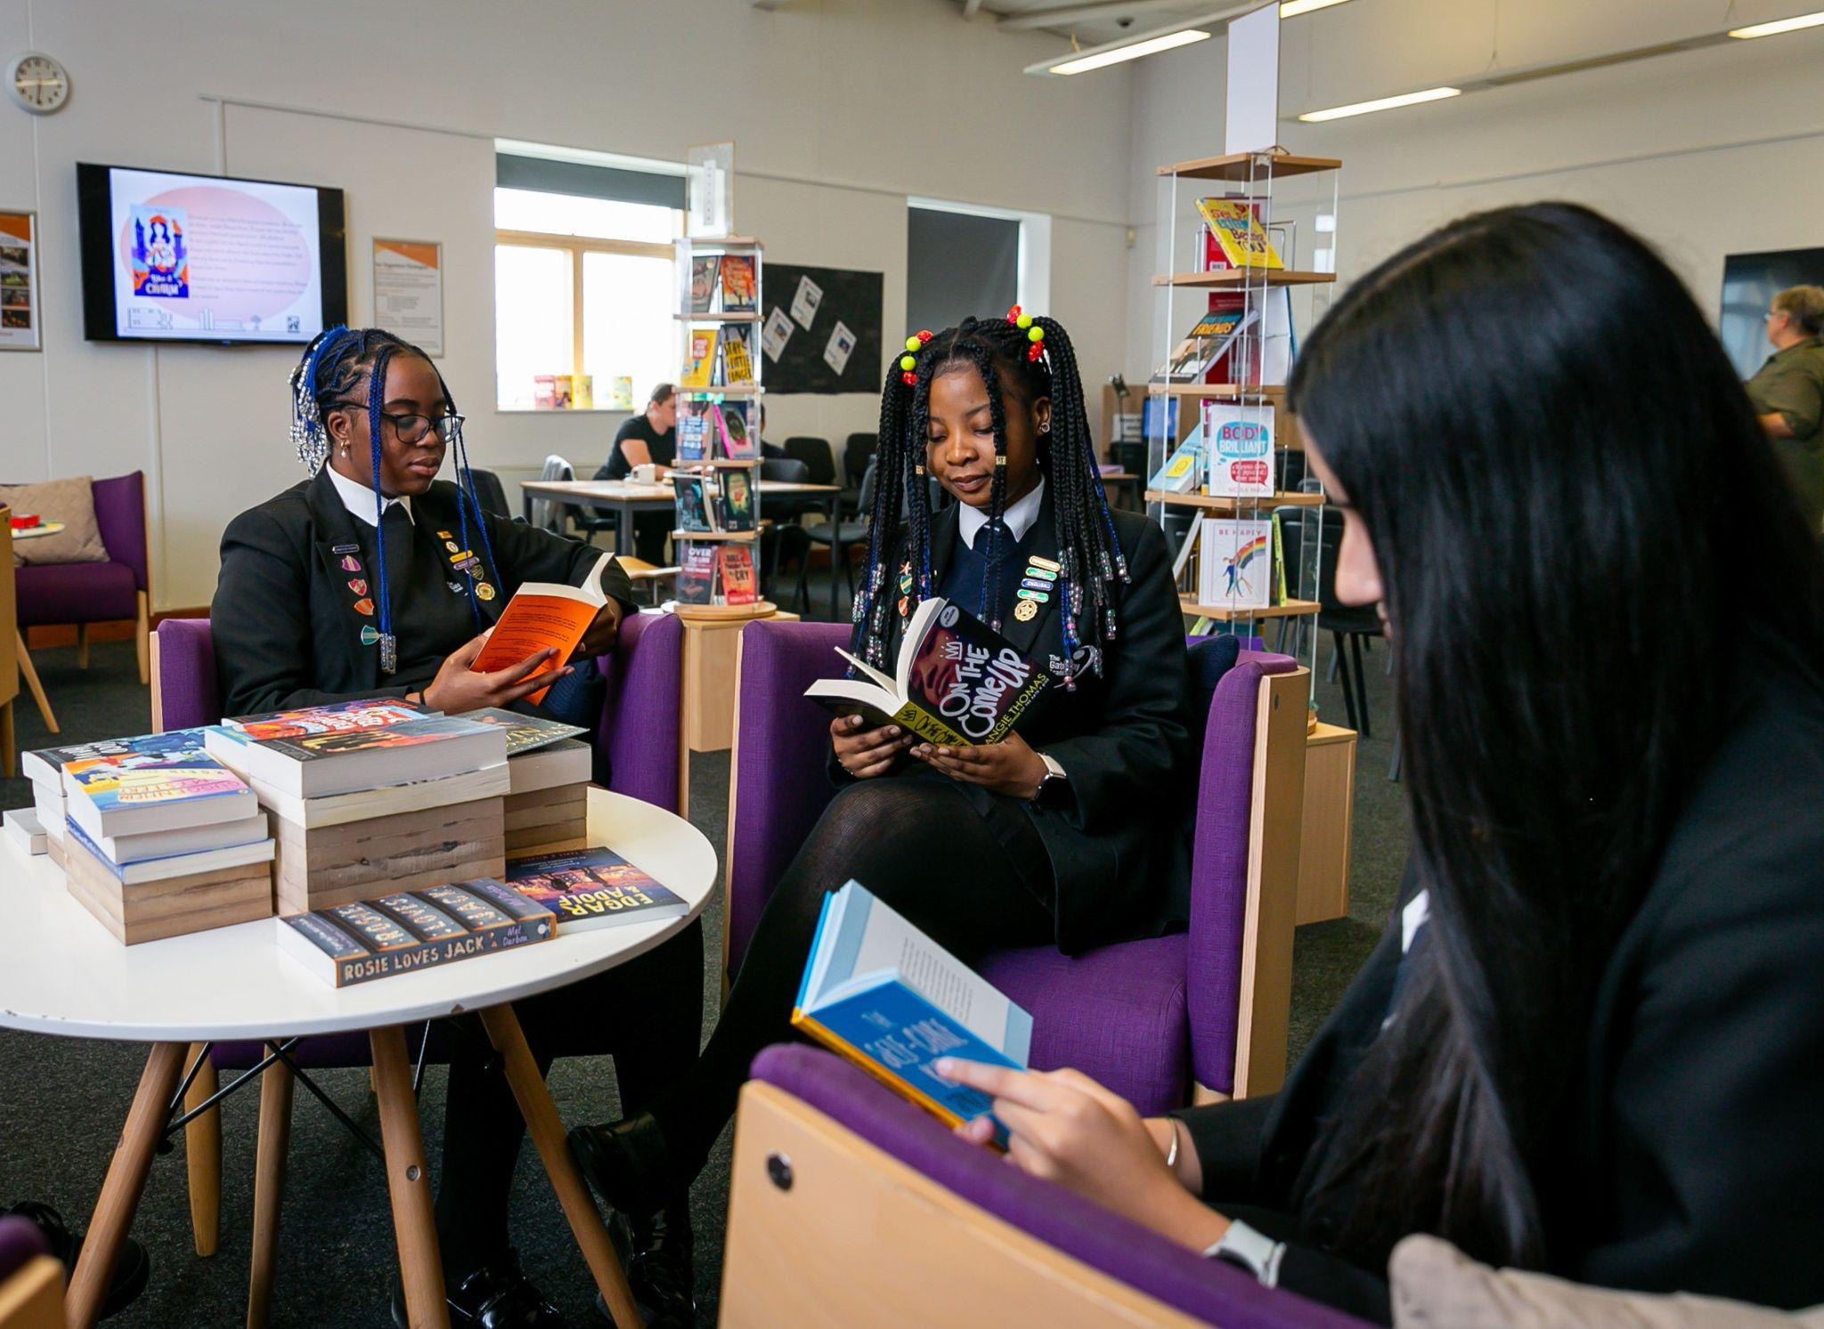
3. Create a Reading-Friendly Environment:
Designate a cosy reading corner or space at home. Provide a variety of reading materials, such as age-appropriate books, comics, magazines, or e-books, to cater to your child's interests.

4. Engage in Discussions:
Discuss the books your child is reading. Ask open-ended questions about the characters, plot, and their favourite parts. Encourage them to express their opinions and predictions about the story. You will get regular updates from the school on what your child is reading- discuss this with them.

5. Visit Libraries and Bookstores:
Take regular trips to the library or bookstores. Allow your child to choose books that captivate their interest. Many libraries also host reading events and workshops that can further engage your child in reading.

