

START DATE:
NEW ADMISSION YEAR GROUP:

IN-YEAR ADMISSION FORM
STUDENT NAME:


Please complete ALL sections in this form IN BLOCK CAPITALS
Section 1: Student Information
STUDENT DETAILS
Student forename: |  | Legal Surname:
Middle name(s) |  | Previous school:
Date of Birth: |  | Gender (Please circle): |  | Male | Female
Address:

Address: |  |  | Postcode:

Information from Birth Certificate/Passport:
This information is a Department of Education requirement.
Have you seen the Birth Certificate/Passport (Office use only) |  | Yes | No
Student country of birth: | Student Nationality:
Religion:
First language: |  | Languages spoken at home:

Doctor details:
Name:
Address:
Section 2: Medical Information
Any known medical conditions/needs (Please circle)? | Yes | No
If YES, please provide as much information as possible in the box below:
Has your child any identifiable special needs (Please circle)? | Yes | No
If YES, please provide as much information as possible in the box below:
Are there any professionals involved? If so, please give names:
Does your child have any problems with their vision, speech or hearing (Please circle)? | Yes | No
If YES, has your child been referred to a specialist? Please provide us with any additional information:


Any known dietary needs (Please circle)? | Yes | No
If YES, please provide as much information as possible in the box below:
Section 3: Contact Details
In case of a sudden illness or minor accident we require that you provide us with
AT LEAST ONE PARENTAL CONTACT and one emergency contact (not the same person).
You may provide us with additional contact details at any time.
CONTACT ONE DETAILS |  |  | CONTACT TWO DETAILS
Relationship  to child: |  |  | Relationship  to child:
Parent  Responsibility  (Please circle): | Yes | No | Parent  responsibility  (Please circle): | Yes | No
Forenames: |  |  | Forenames:
Surnames: |  |  | Surnames:
Date of Birth: |  |  | Date of Birth:
NI Number |  |  | NI Number
Occupation: |  |  | Occupation:
Work address: |  |  | Work address:
Work Phone No. |  |  | Work Phone No.
Home Telephone No. |  |  | Home Telephone No.
Mobile: |  |  | Mobile:
Email: |  |  | Email:
Is the student ‘In Care’? |  |  |  | Yes | No

Please give TWO names and emergency telephone numbers if parents/carers cannot be contacted:
Name: |  | Relationship  to person: |  | Telephone No.
Name: |  | Relationship  to person: |  | Telephone No.

Information of any other children in the family/household and what school they attend:
Name: |  | Date of Birth: |  | School:
Name: |  | Date of Birth: |  | School:
Name: |  | Date of Birth: |  | School:
Name: |  | Date of Birth: |  | School:

Section 4: Additional Information
Travel Arrangements (Please circle only one box):
Walk | Cycle | Car | Public Bus | Taxi | Train | Other

Food Arrangements - Please circle the appropriate option below:
Free School Meals* | School Meals | Packed Lunch
*Please can you complete the online application form, via the Thurrock Council website:

https://www.thurrock.gov.uk/school-meals/free-school-meals

Online Learning
Do you have access to the Internet? | Yes | No

Devices Available for Online Learning
Computer/Laptop | Tablet | Smart Phone |  | Other |  | None
Is the device shared between more than 1 person? |  |  | Yes |  | No
PLEASE TICK ONLY ONE OF THE FOLLOWING BOXES
□ ANY OTHER ASIAN BACKGROUND | □ GYPSY/ROMA
□ ANY OTHER BLACK BACKGROUND | □ INDIAN
□ ANY OTHER ETHNIC GROUP | □ INFORMATION NOT YET OBTAINED
□ ANY OTHER MIXED BACKGROUND | □ PAKISTANI
□ ANY OTHER WHITE BACKGROUND | □ REFUSED
□ BANGLADESHI | □ TRAVELLER OF IRISH HERITAGE
□ BLACK – AFRICAN | □ WHITE - BRITISH
□ BLACK – CARRIBEAN | □ WHITE - IRISH
□ CHINESE | □ WHITE & ASIAN
□ BLACK EUROPEAN | □ WHITE & BLACK AFRICAN
 | □ WHITE & BLACK CARRIBEAN

PARENT / GUARDIAN AGREEMENT
Please tick boxes to grant permissions:
I confirm that I have received and read through the school admissions booklet including the appendices and have explained the following to my child:
- The Gateway Learning Community
- Safe use of Internet in school

The Parent/Guardian Agreement - Appendix 1
I have read and understood The Gateway Learning Community Home/Academy agreement, and explained the contents to my child.

Internet Parent permission - Appendix 2
As the parent or legal guardian of the student signing below, I grant permission for my child to use electronic mail and the Internet. I understand that students will be held accountable for their own actions. I also understand that some materials on the Internet may be objectionable and I accept responsibility for setting standards for my child to follow when selecting, sharing and exploring information and media, and understand that the Local Authority maintains a filtered access to The Gateway Learning Community network.

Privacy Notice - Appendix 3
Privacy Notice – I am aware that student information is shared with relevant departments and regulated by the Data Protection Act.
Participation in regular activities - Appendix 4
I give permission for my son/daughter to be taken out of the school grounds under the supervision of a member of staff for the purpose of school activities.

Still and Moving images
I agree to allow my child to take part in photography (still & moving image) arranged by The Gateway Learning Community (or its agents).
I understand that the images may be used for marketing, promotional and educational purposes by The Gateway Learning Community (or its agents), and may be published and broadcast in any media including the internet.
I waive all present and any future rights to the images, including copyright, artistic rights and intellectual rights.
In making this application I/We agree that I/We will make every effort to ensure that I/We commit ourselves to The Gateway Learning Community/Parent Partnership

Parent/Guardian Signature (1): …………..………….………..…..….. Print name: …………………...………..… Date: …..……...…

Parent/Guardian Signature (2): …………………………..………..…. Print name: ……………….….……..……. Date: ………………

Student Agreement
- I have read/understood the student agreement in The Gateway Learning Community agreement.
- As a Gateway Learning Community user of the Internet, I agree to comply with the rules on its use. I will use the network in a responsible way and observe all the restrictions explained to me by The Gateway Learning Community.

Student Signature: …………………………………………………… Print name: ………………….………………Date: ……….……...
THE GATEWAY LEARNING COMMUNITY
HOME / ACADEMY CONTRACT

All members of the Gateway Learning Community commit to working together to support the GLC mission and to uphold the GLC values at all times [including on line]:

Each GLC Academy is responsible for:
- Communicating clear measures to support good order, respect and discipline;
- Ensuring that the GLC’s Behaviour Policy does not discriminate against any student;
- Providing appropriate training for all GLC staff [including SEN and disability and mental health], and identifying where further support is needed. This includes a clear induction for new staff regarding the Academy’s culture to ensure they understand its rules and routines, and how best to support all students to reach their potential;
- Building positive relationships with parents /carers and students, working together to celebrate positives and address behaviour that does not meet expectations;
- Ensuring that the Academy environment encourages positive behaviour;
- Ensuring that all staff understand the behavioural expectations and the importance of maintaining them. Monitoring how staff implement this policy to ensure rewards and consequences are applied consistently to all groups of students;
- Ensuring that the behaviour data is reviewed regularly, to make sure that no groups of students are being disproportionately impacted;
- Playing an active part in the life of the GLC and their Academy including acting as ambassadors;
- Supporting the admission and transition of students with parents, students and other agencies.
Every young person who attends a GLC Academy is responsible for:
- Adhering to and promoting the GLC motto, mission and values;
- Following instructions by GLC staff, obeying GLC rules and accepting consequences in an appropriate way;
- Being in school, on time and equipped for learning;
- Doing classwork and home learning to at least the expected standard, attending additional learning periods if not making expected progress;
- Using electronic devices appropriately including ensuring what is accessed, posted and received is acceptable and follows the GLC motto, mission and values;
- Playing an active part in the life of the GLC and their Academy including acting as ambassadors.
Every parent / carer who has a child at a GLC Academy is responsible for:
- Respecting and supporting the GLC’s Behaviour Policy, motto, mission and values;
- Informing the Academy of any change in circumstances which may impact on their child’s progress and/or behaviour and actively engaging with the support offered;
- Playing an active part in the life of the GLC and their Academy including acting as ambassadors by always setting the best example possible for impressionable young people;
- Discussing any behavioural concerns with the appropriate member of staff promptly and take the necessary action at home to support their chid in making positive choices;
- Ensuring their child is in school, on time and equipped for learning;
- Ensuring their child does their home learning to the expected standard, attends additional learning periods if they are not making expected progress;
- Attending meetings with the Head of School or other Academy staff, if requested, to discuss their child’s progress, attendance and/or behaviour;
- Adhering to the terms of any Parenting Contract, Support plan, the GLC Home-Academy Contract or order relating to their child’s behaviour.
- Ensuring their child uses their electronic devices appropriately including actively monitoring what their child is accessing, posting and receiving.

Member of the GLC Academy: Mrs McLaughlin Head of School

Child’s name: …………………………………………………………………………………………………………………...

Parent/ Carer signature ………………………………………………… Date: …………………………………

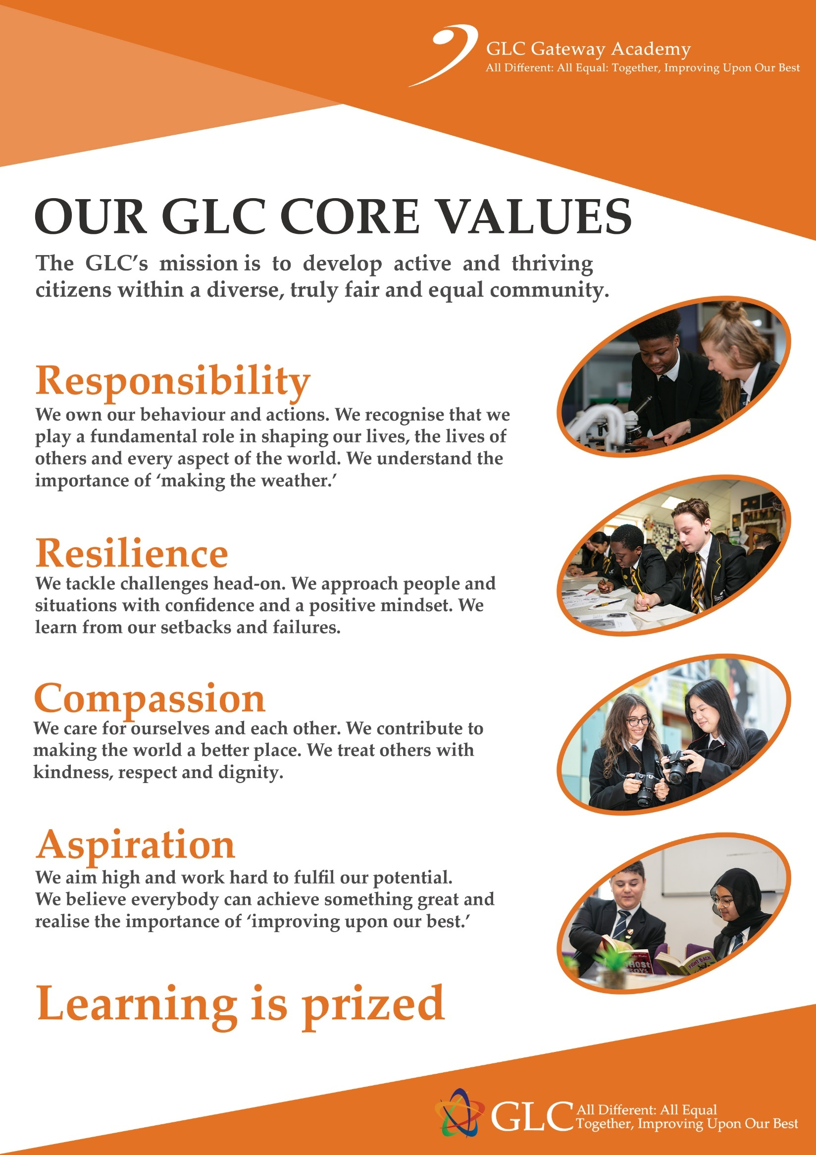


FOR OFFICE USE ONLY:
File Requested: …………………………. Date received: ………………………….… Reg group: ………………
CTF Requested: …………………..…….. Date received: ……………………………
Birth Certificate/Passport seen: Yes No

SEN: ………………………………… Medical: …………………………………… EAL: …………………………….



